|  |  |
| --- | --- |
|  | **2015** |
| Y | Akshay Pandey  Dheeraj Mukati  Yukti Sarwadia |

|  |
| --- |
| **Assignment1 _01 - Web Tech** |
| **Biker's Club** |

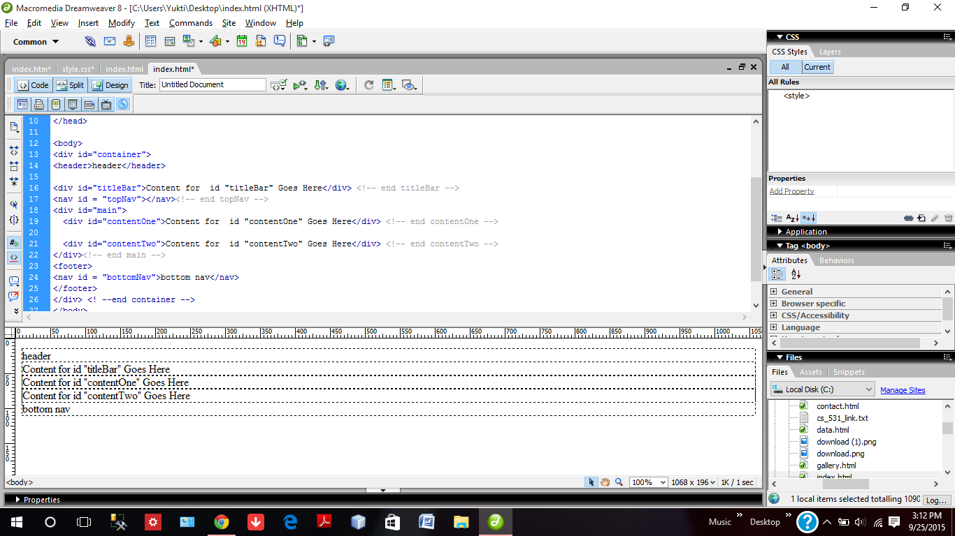

Creation of the basic structure of our club website using Dreamweaver by defining the div.

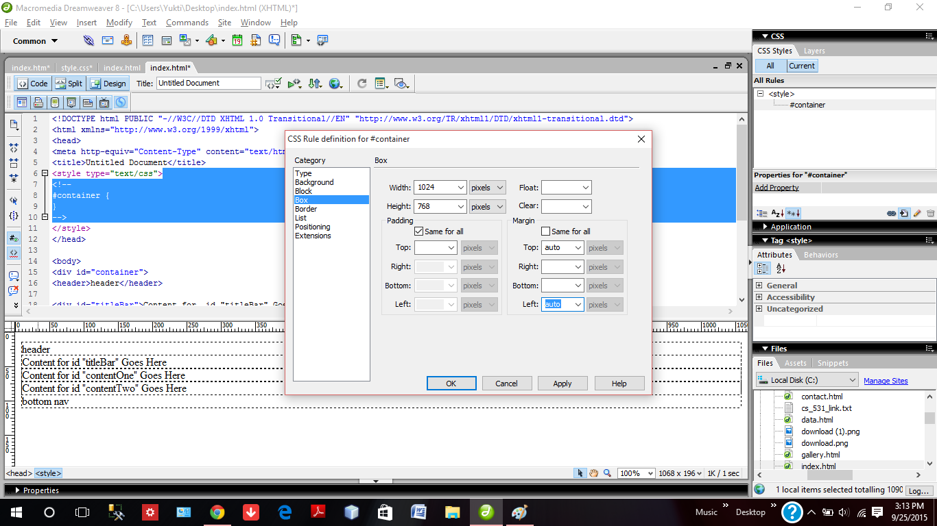

Setting the properties for different div by assigning them values in CSS properties.

Structure of the website after setting some basic CSS properties.

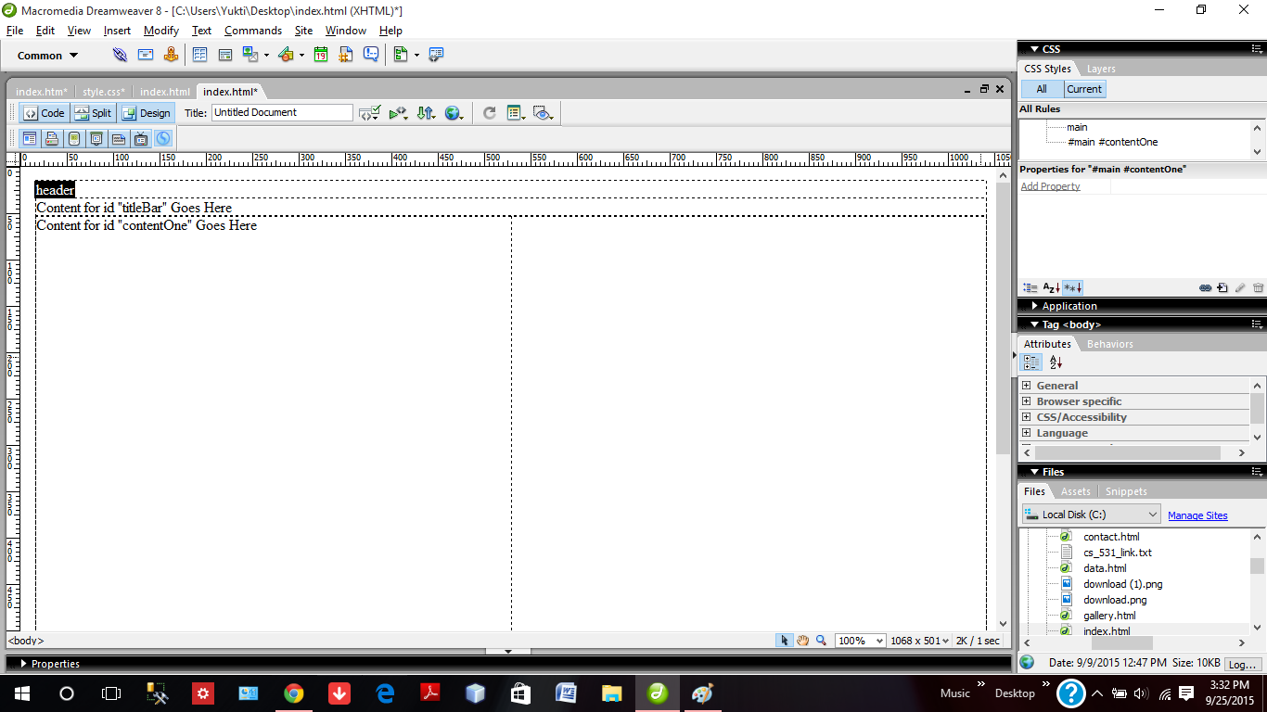

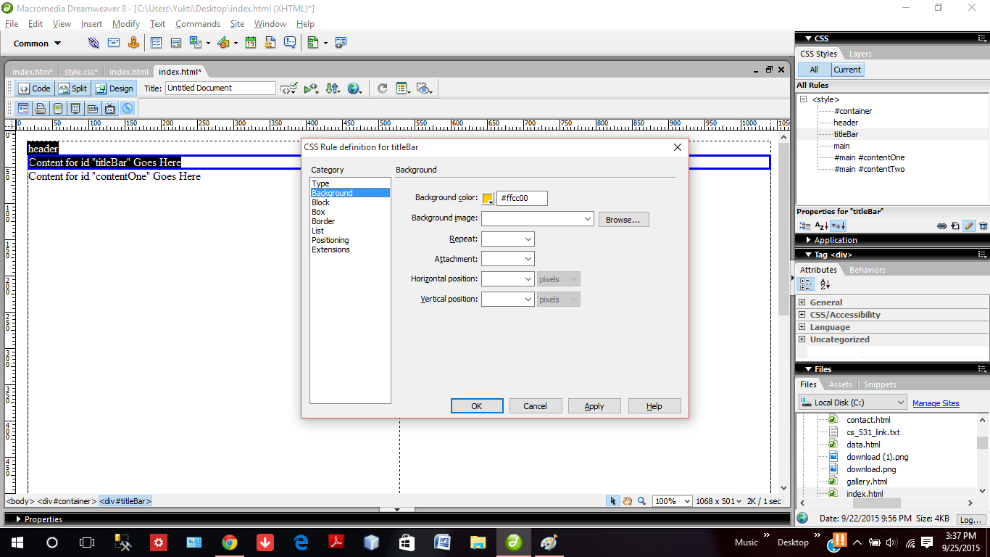

Setting background colors to the page.

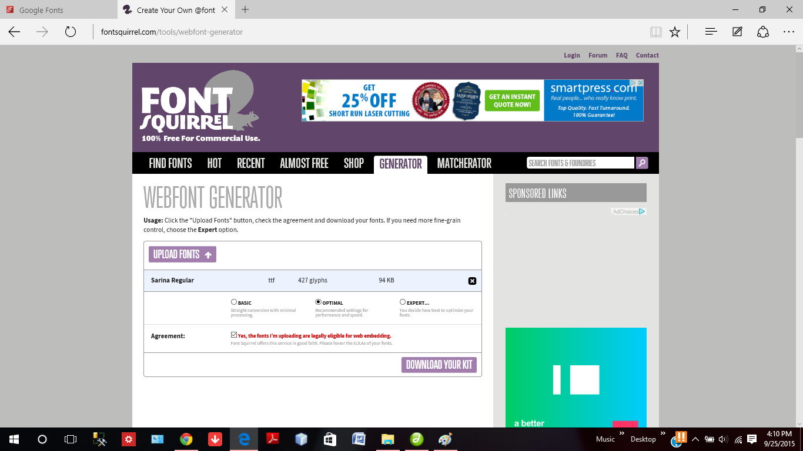

Font downloaded from Font Squirrel to use them in website.

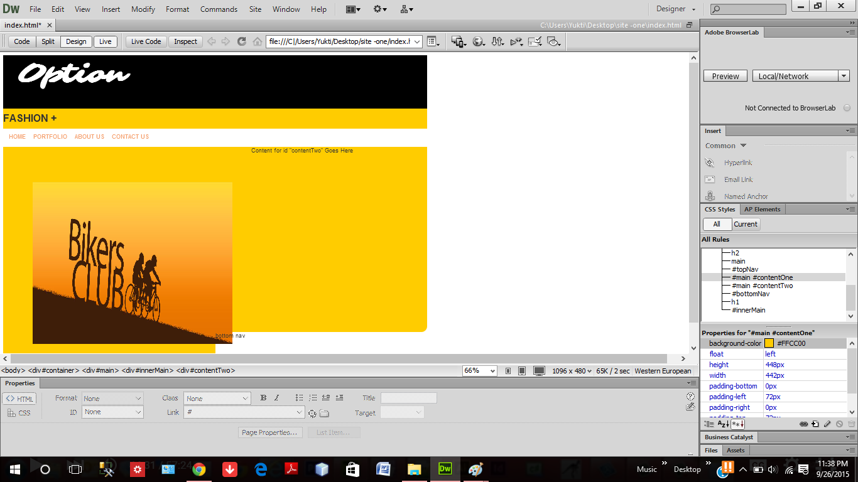

Using the img src tag to paste the image on the structure.

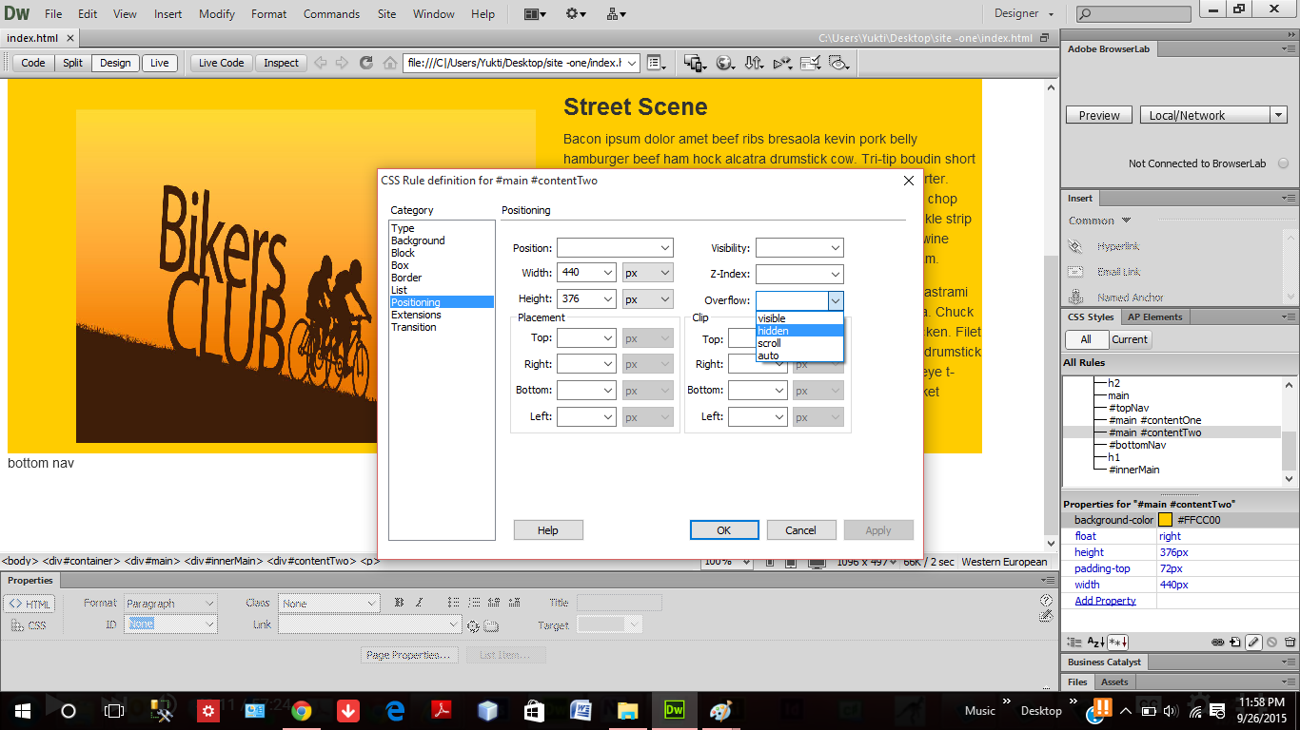

Arrangement of the image and the text and setting the padding, align and font properties.

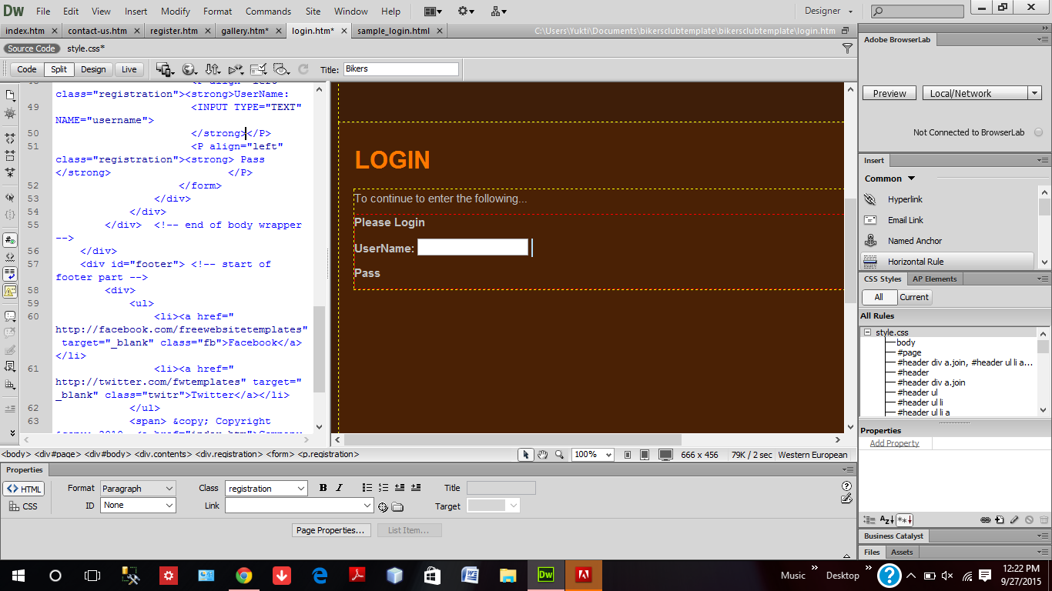

Login Page design which includes text field for Username.

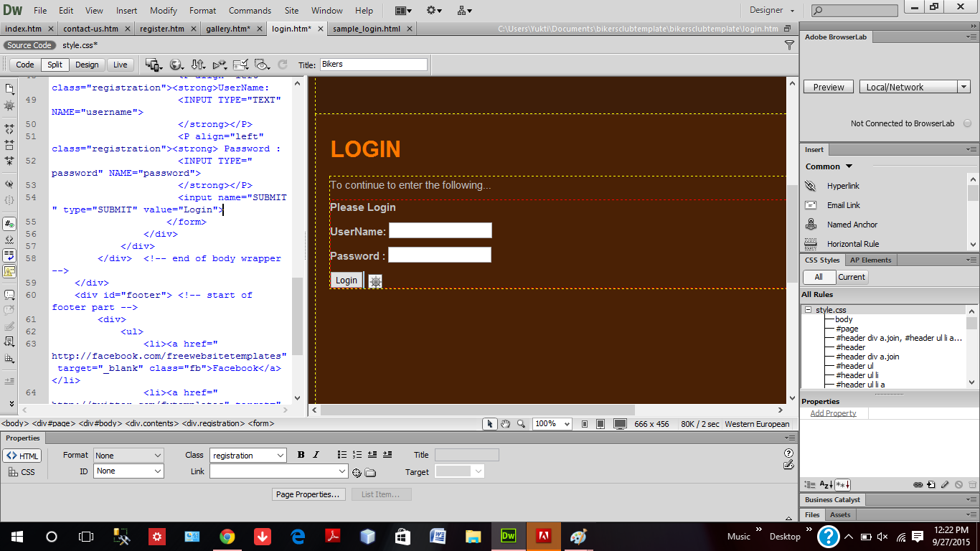

Login Page design which includes text field for Password.

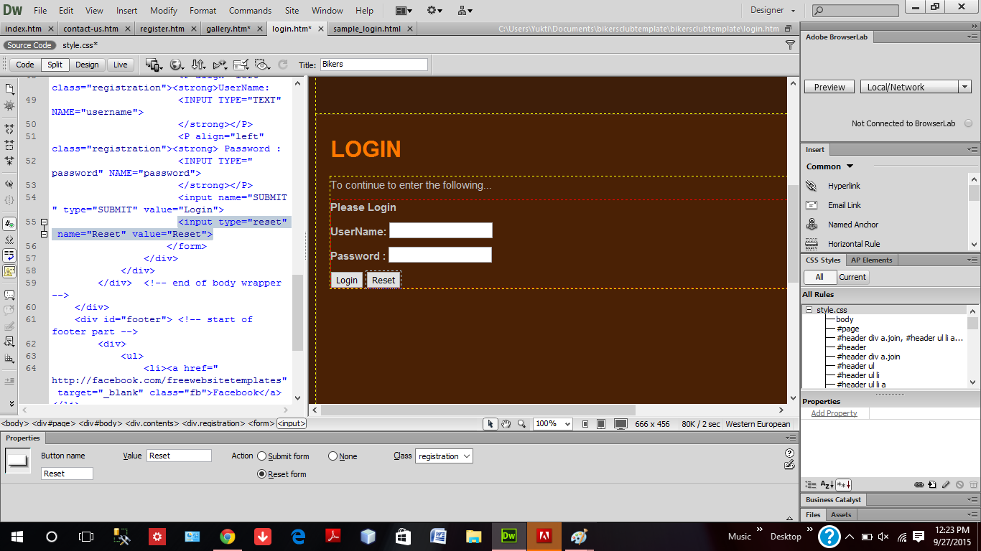

Complete Login page after the addition of the two fields.

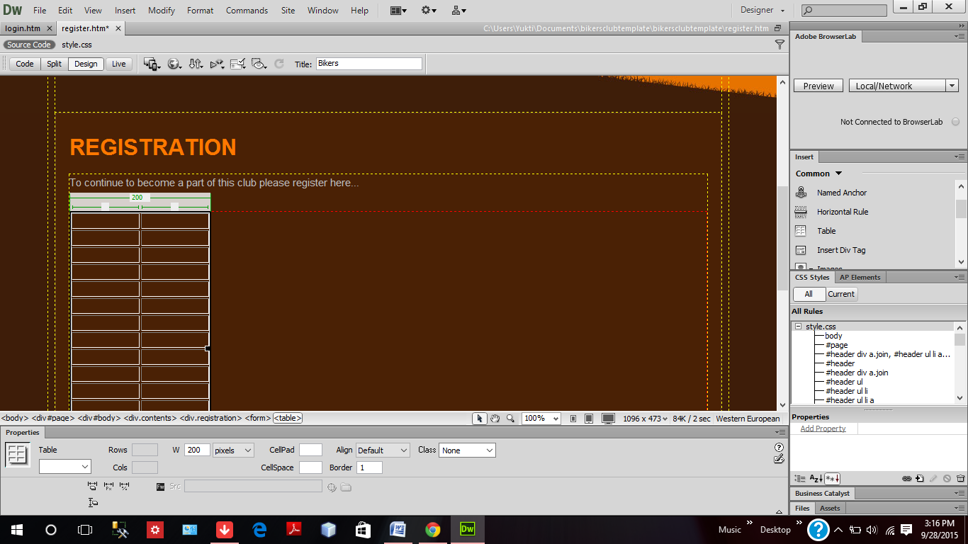

Creation of table which is used to store the registration fields.

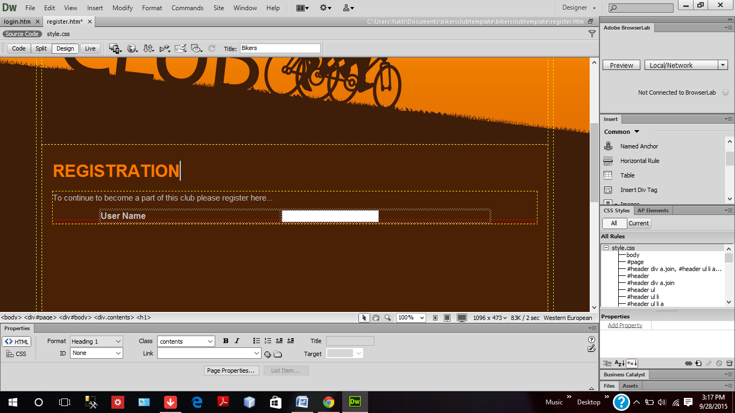

Adding text fields, radio button, check box, combo box, dropdown list and other HTML elements.

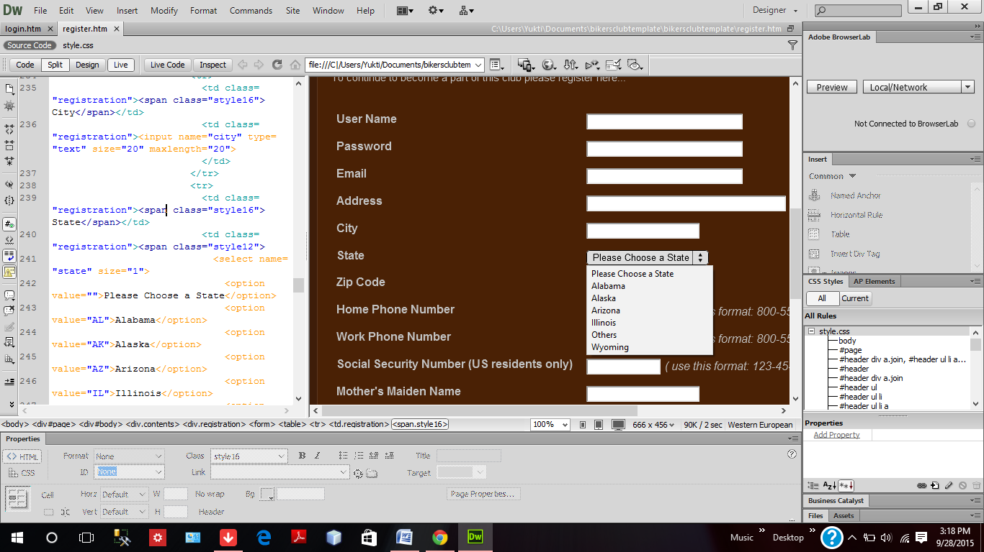

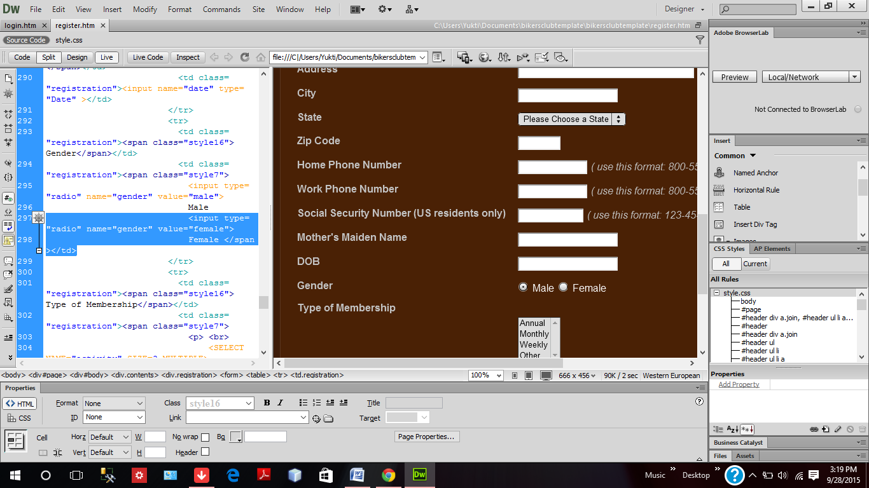

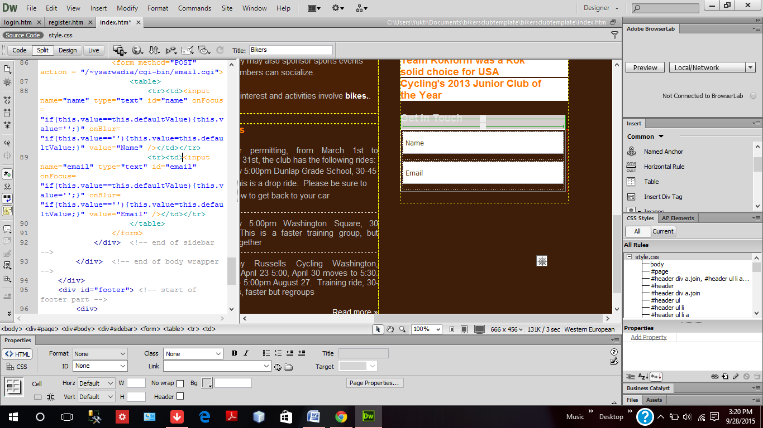

The feedback form which contains text fields and text area .

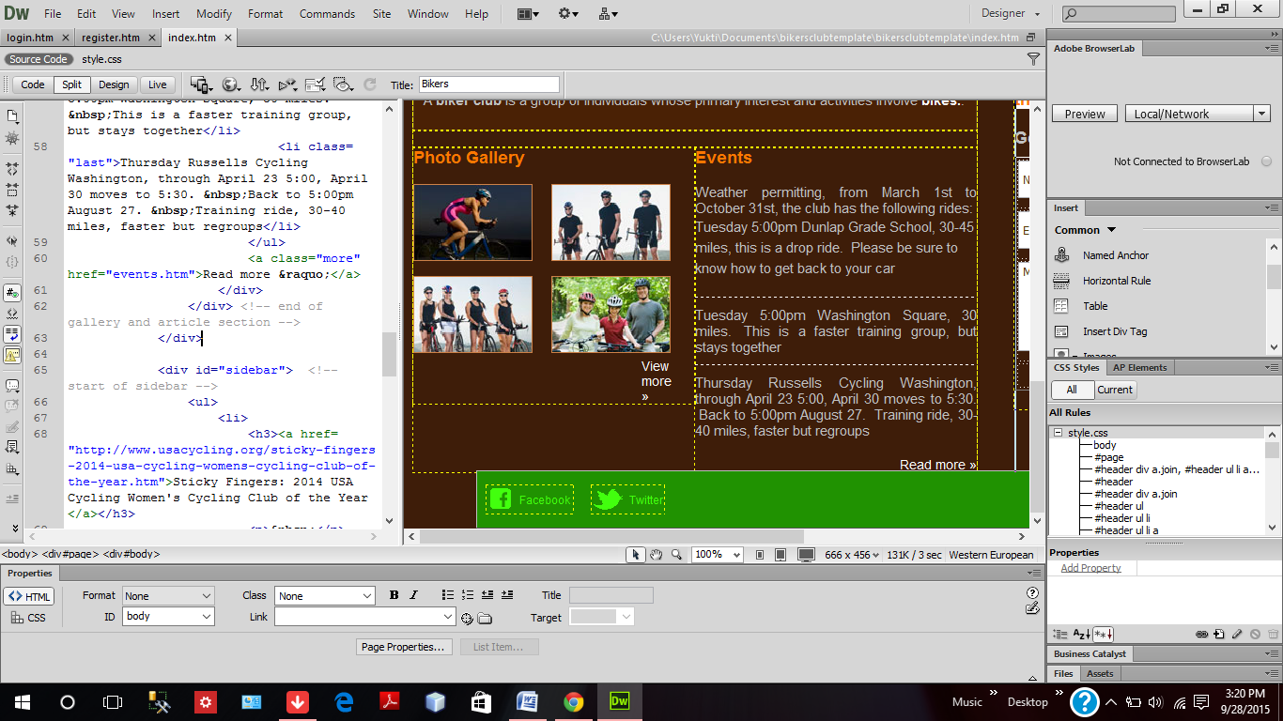

Addition of the footer containing links to face book and twitter.

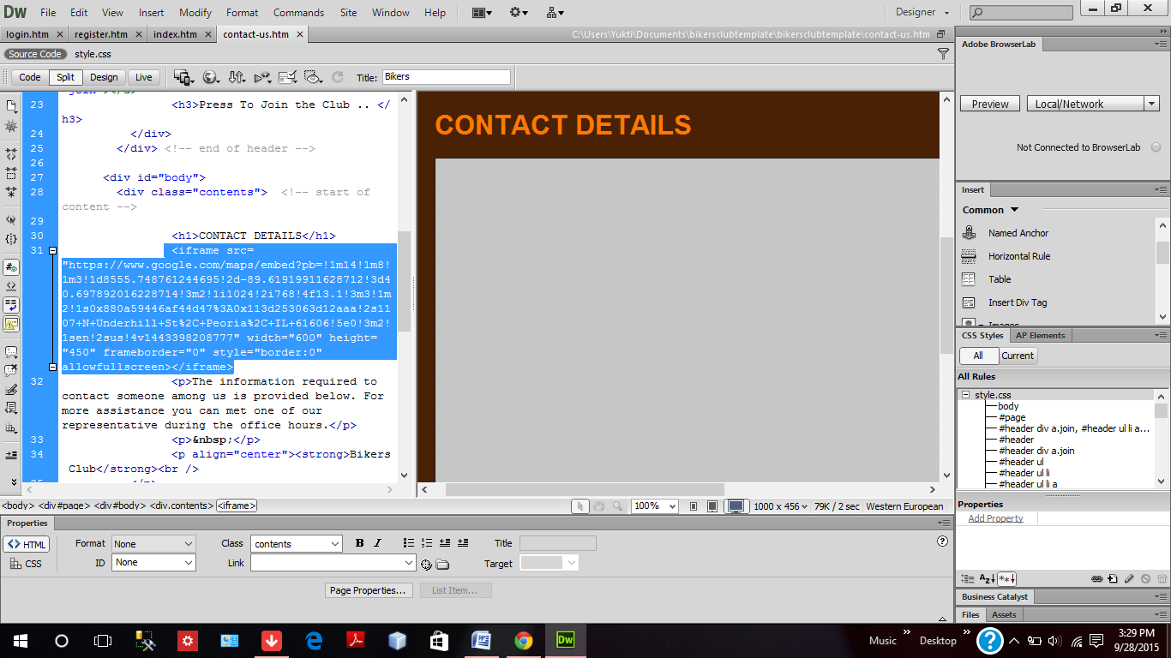

Use of IFrame tag to include the Google map feature to display the location.

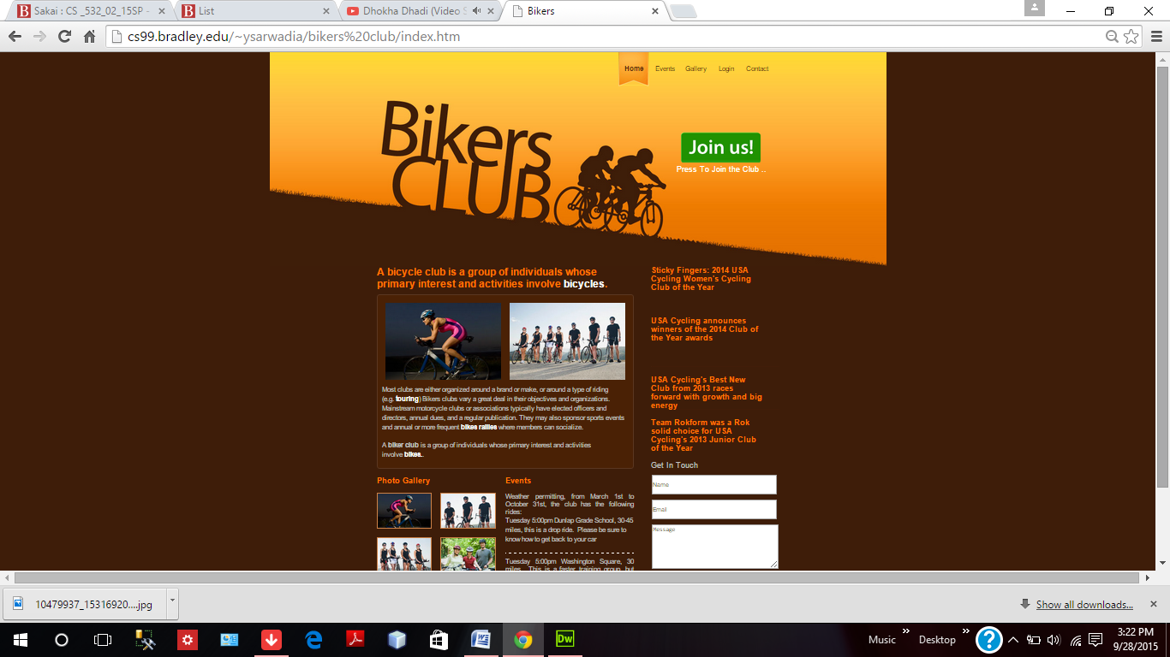

Home Page on cs99 with details about the club , feedback form and links to other pages of the website.

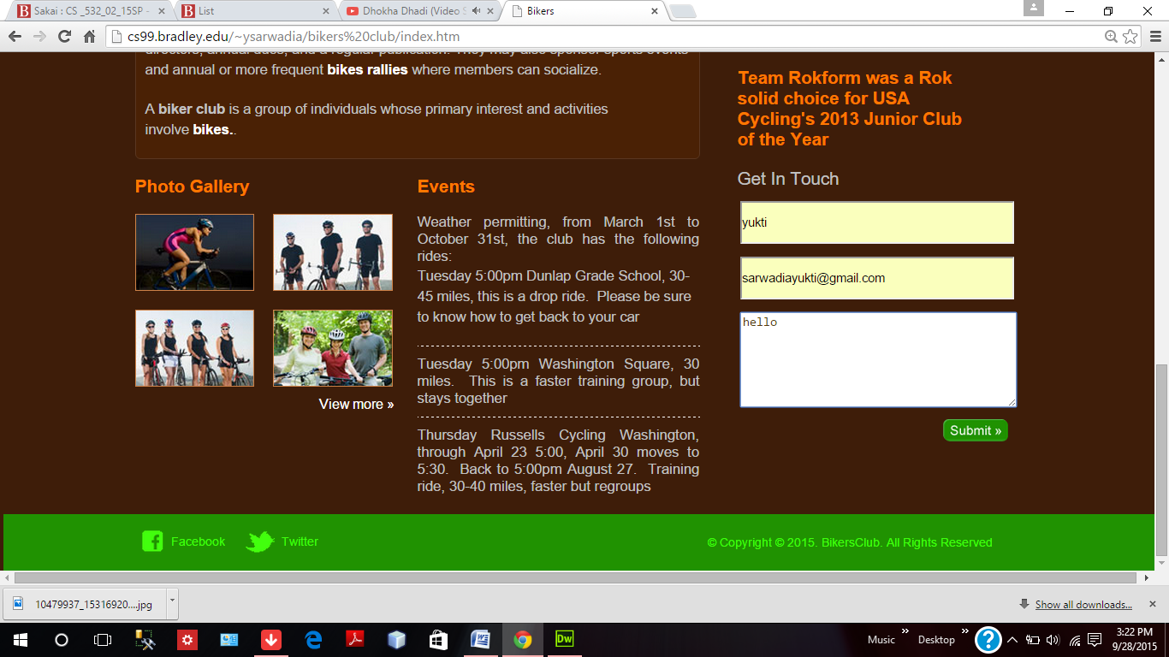

Entering information in the feedback form to provide feedback.

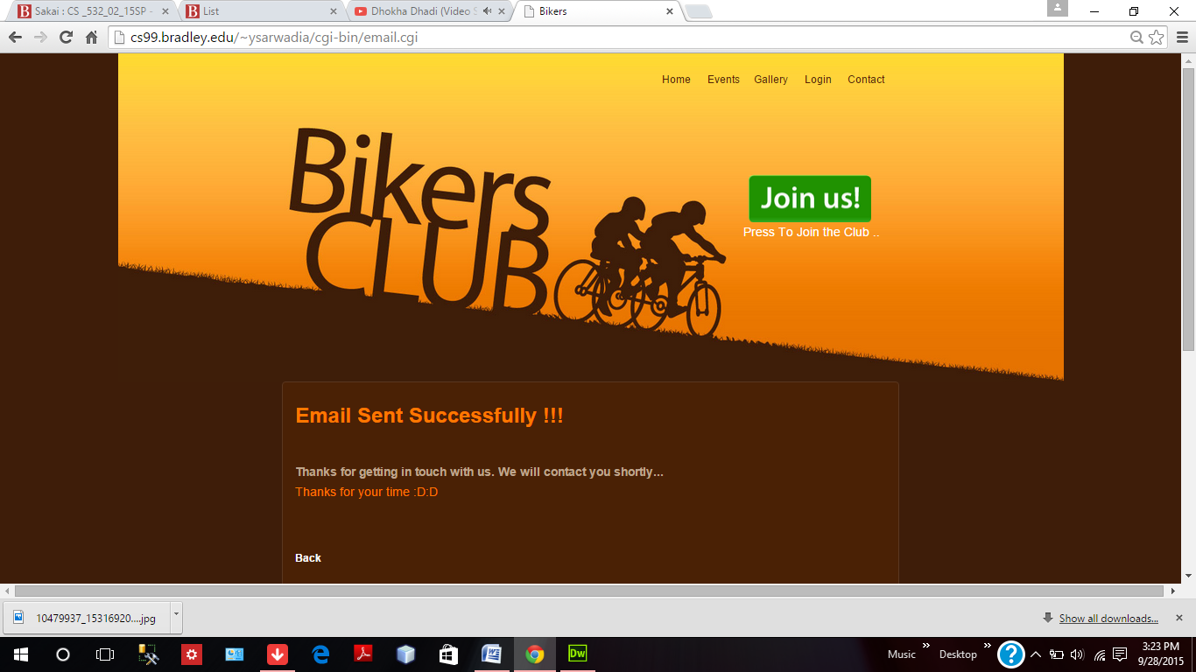

Response of the feedback submit function.

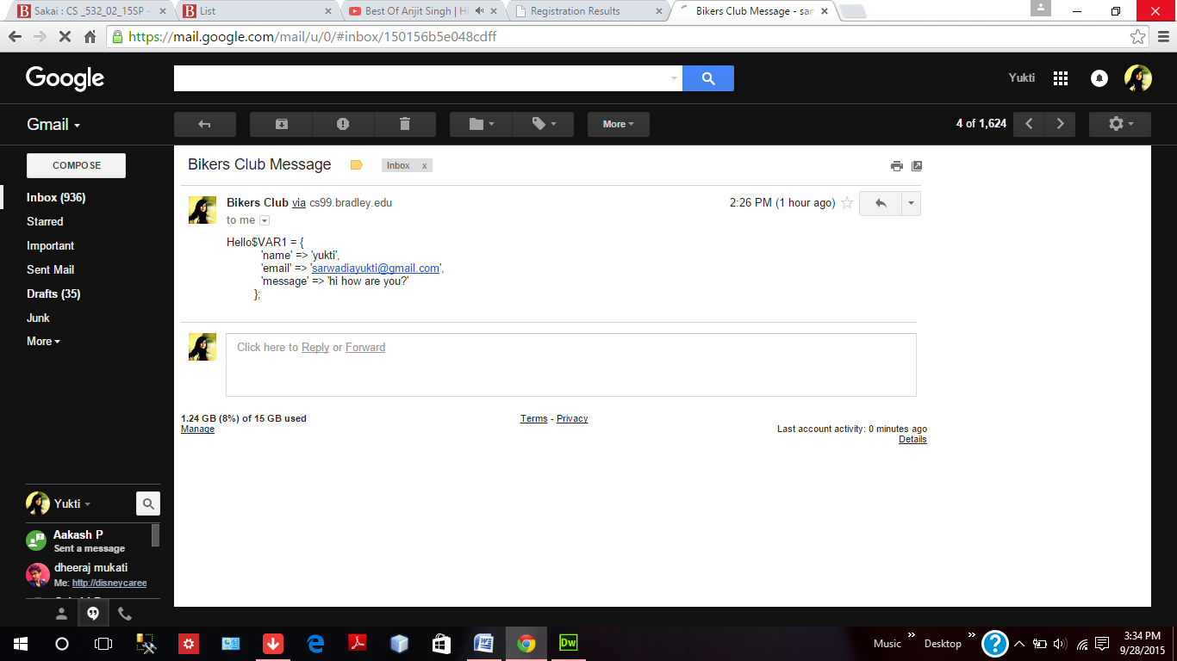

Feedback form Information sent via email.

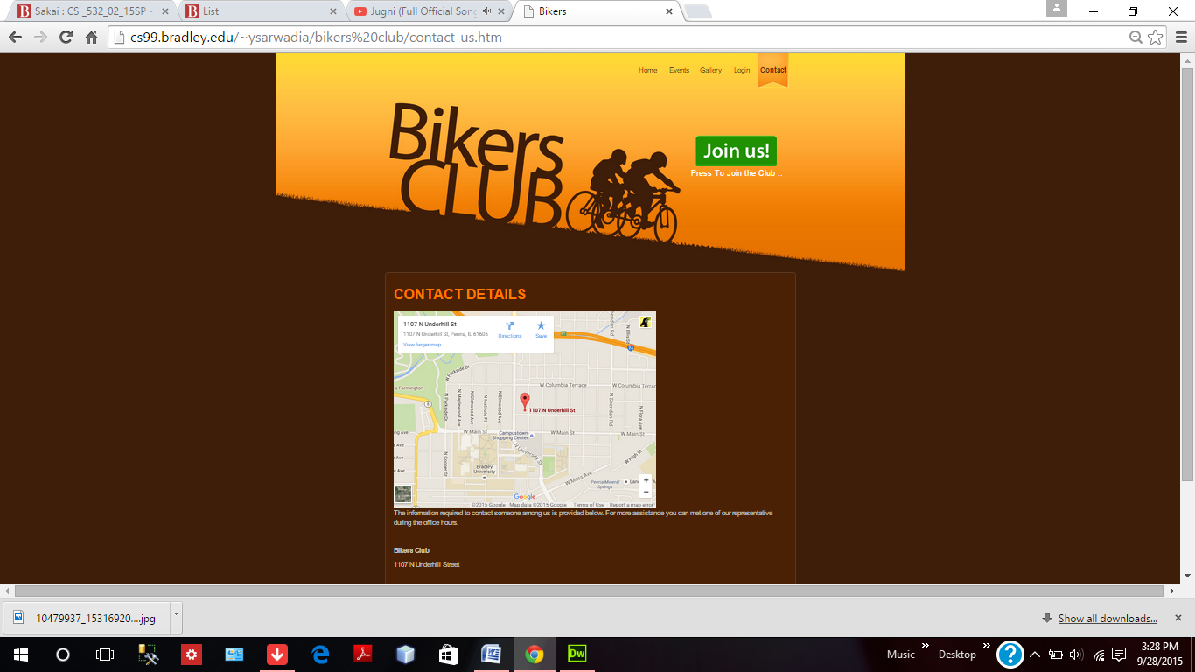

Contact Us Page with Google Map Integration.

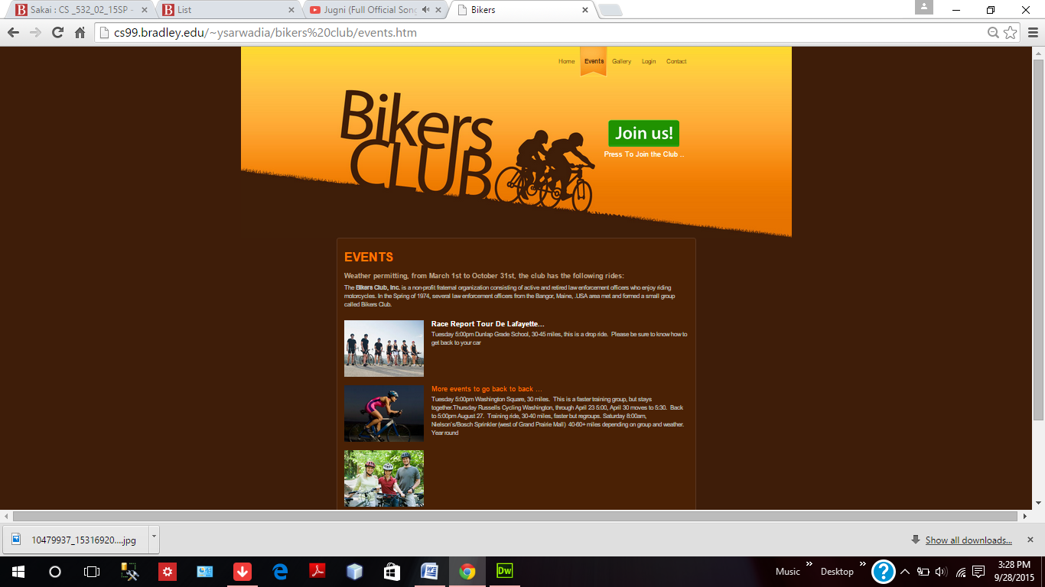

Pages showing upcoming events and images related to club.

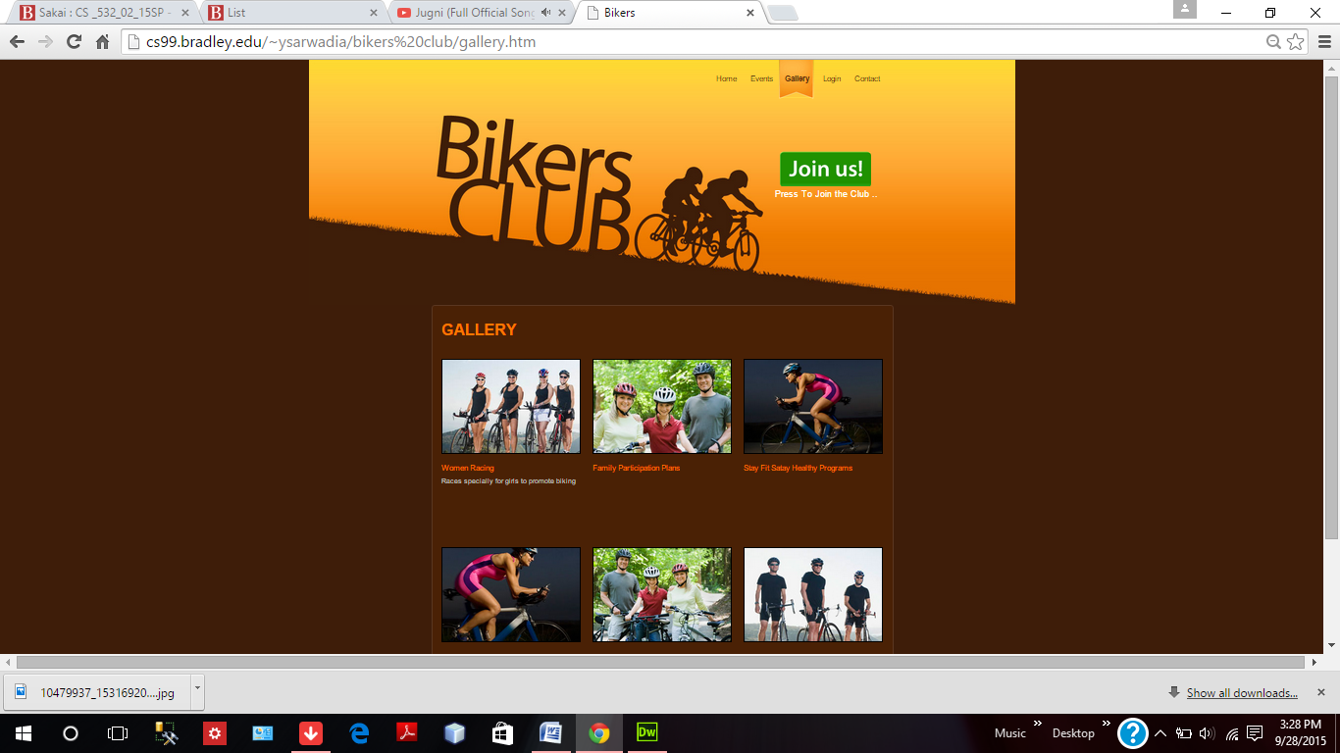

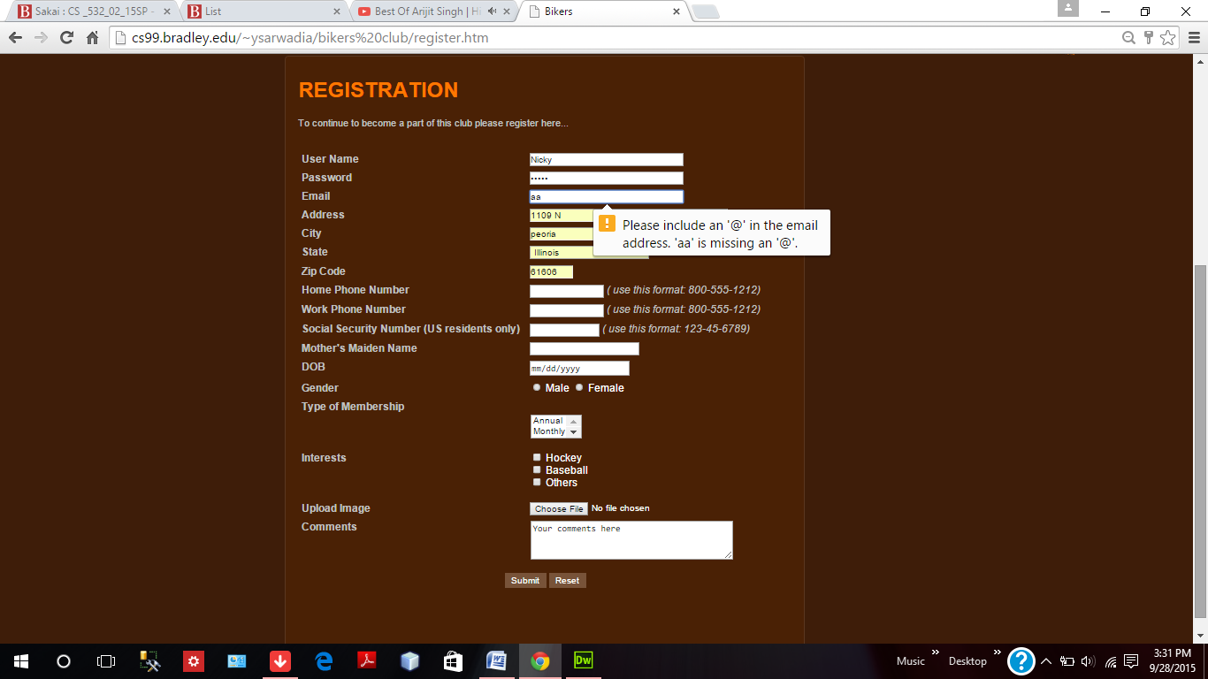

Registration form with some simple HTML5 components like email field.

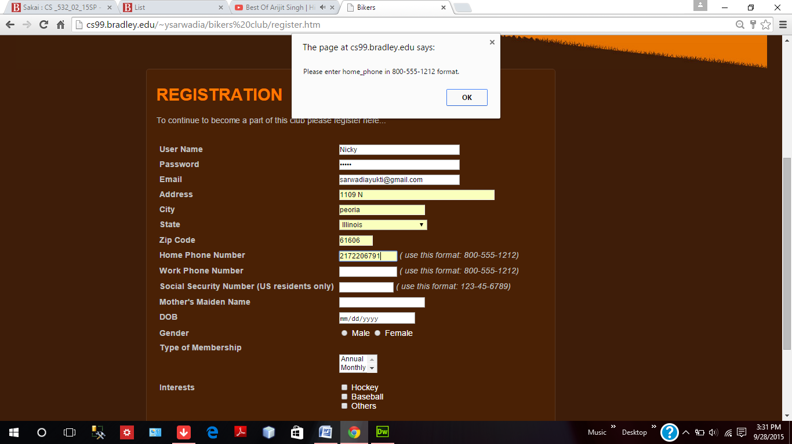

JavaScript validations for work phone number, home phone number and social security.

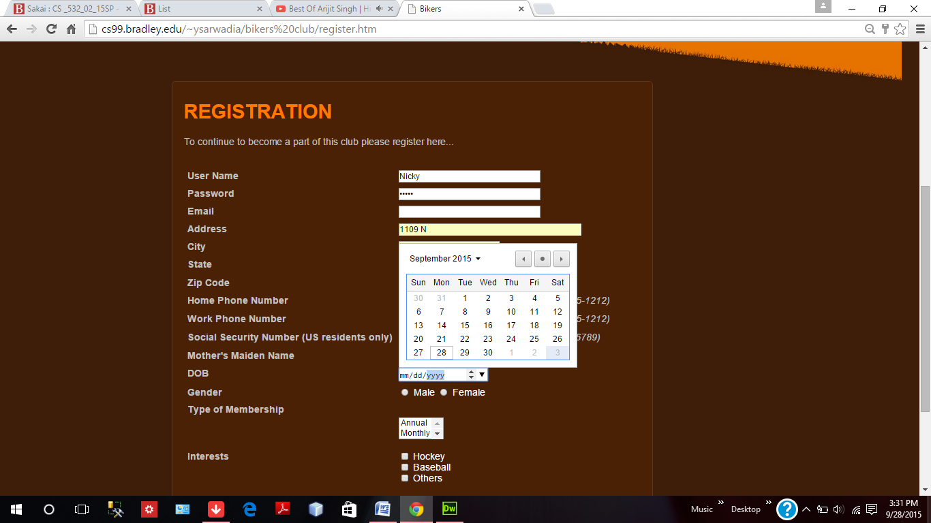

Calendar again an HTML5 component used here.

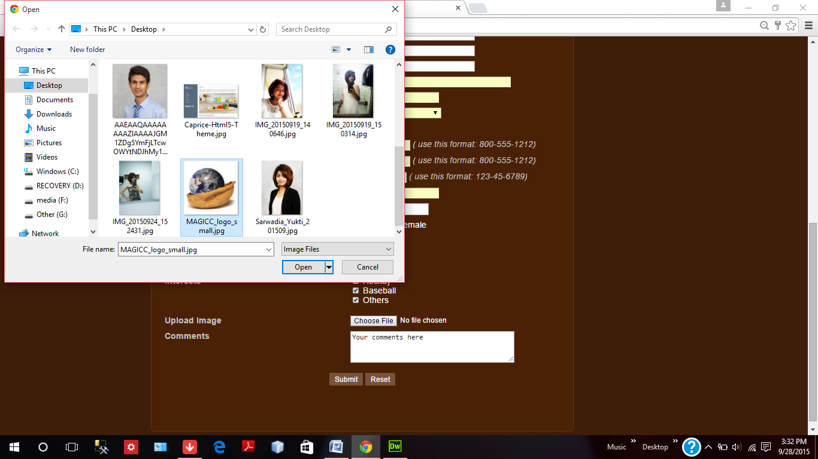

Image upload HTML file component.

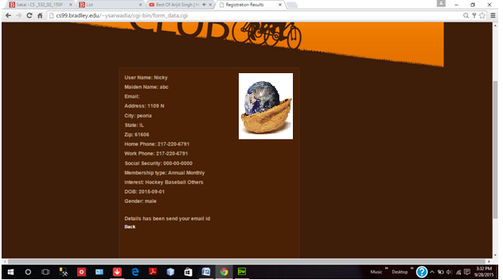

Details after form submission and email sent message.

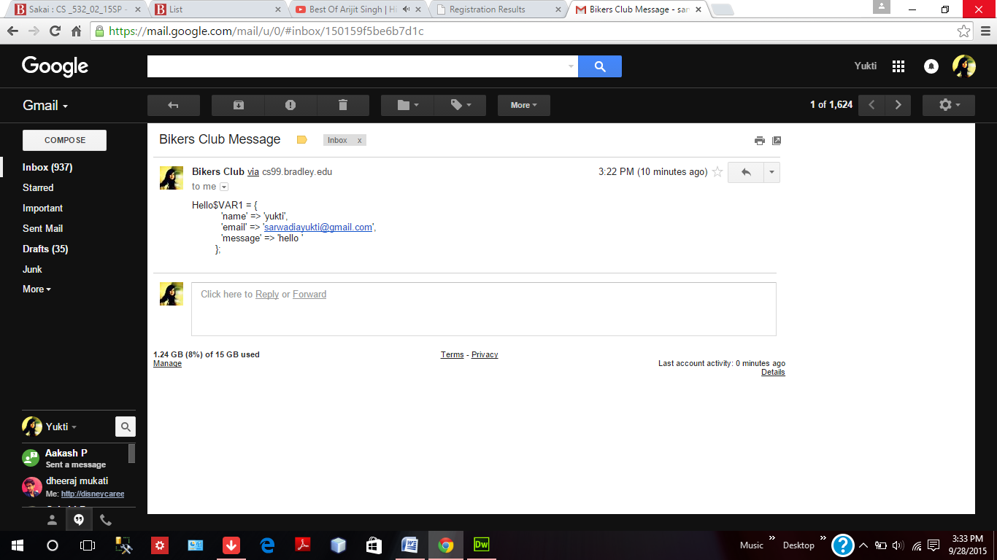

Email sent after the registration form submission stating the registration form details.